NodeMCU Getting Started and Web Server Application

Introduction
NodeMCU is an open source firmware and development platform that helps you to develop rapid prototypes for IoT based applications etc. You can use Lua programming language to write apps but now there is arduino sketch support for NodeMCU. Of course behind the arduino there is a huge communities, supporters etc. Thus we will use arduino sketch in applications.

Installation for windows
NodeMCU includes CH340G USB-UART converter to communicate with computer. First you should install required driver for CH340G. Here you can download driver for CH340G. Also as you know the given links in the document could be broken in a time. Thus you could be search them in the internet if they broken.
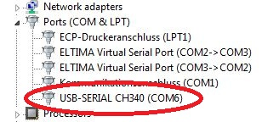

Figure 1
After driver installation as you see at figure 1 the new serial port connection(COM6) gonna occur on your computer. That's it! Now your computer ready to use NodeMCU.

Arduino sketch installation and NodeMCU implementation
If you don"t have arduino sketch in your computer you can install here.
After installation you should follow few steps they are listed below:
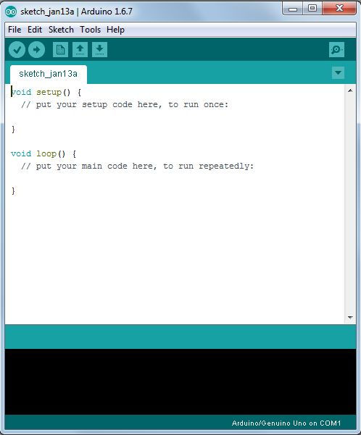
-Run Arduino Sketch

Figure 2
- Go to File --> Preferences menu and add the link
http://arduino.esp8266.com/versions/2.0.0/package_esp8266com_index.json
to the Additional Boards Manager URLs. Also you can seperate URLs by placing comma between them.
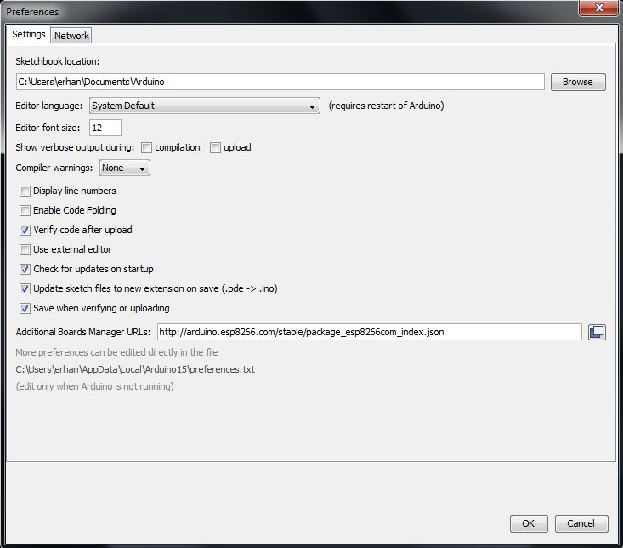

Figure 3
- Go to Tools --> Board --> Boards manager
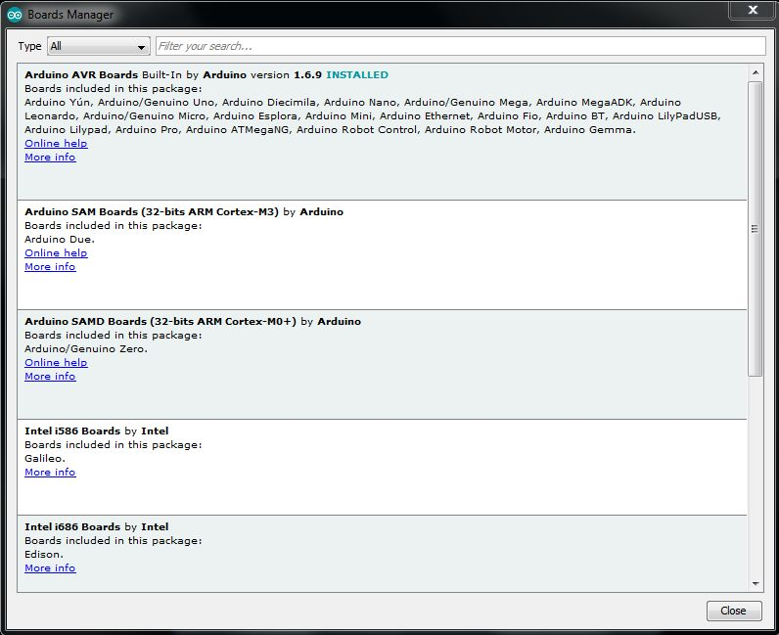

Figure 4
- Now you should have ESP8266 support. Search for ESP8266 and install it.
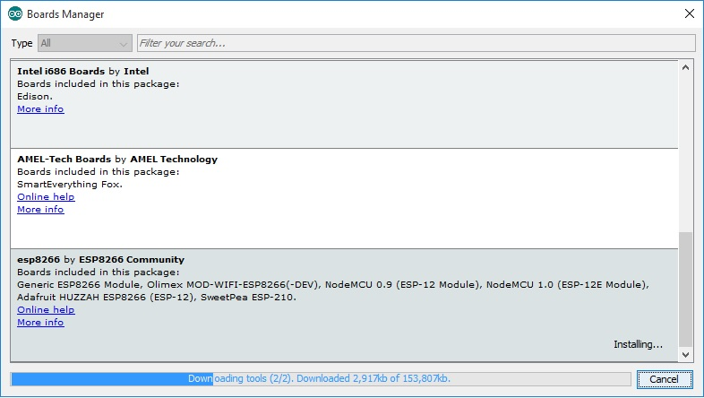
Figure 5

- Go to Tools --> Board and select proper NodeMCU board that you have.
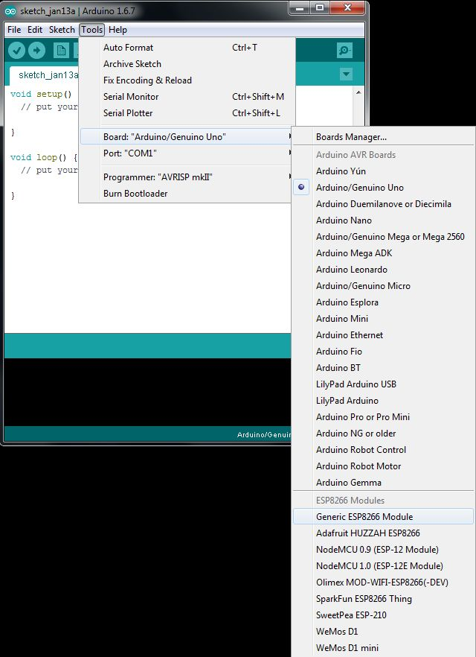

Figure 6
- Go to Tools --> Port and select port to connect NodeMCU.
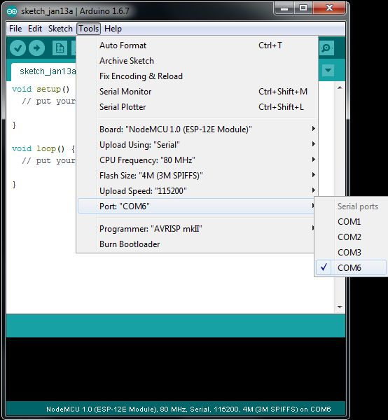

Figure 7
Congratulations! You are ready to write code for NodeMCU with arduino sketch. You can check example codes from File --> Examples menu.
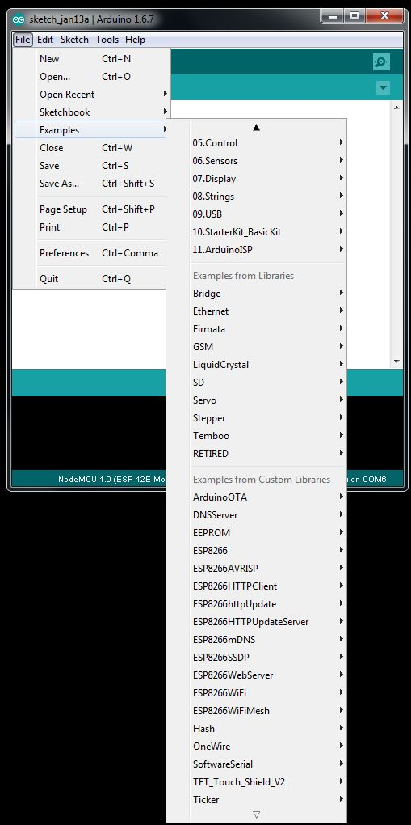

Figure 8

